



LAB MANUAL
Method Overloading in Python

Disclaimer: The content is curated from online/offline resources and used for educational purpose only
Method Overloading in Python

Objectives:
- To simulate method overloading in Python, where a single method is used to perform different behaviours based on the number or type of parameters.
- Python does not support method overloading directly as seen in languages like Java or C++, but we can simulate this behaviour using default parameters.
- To demonstrate how we can implement a method that behaves differently based on the provided arguments using a simple Printer class that prints messages a specified number of times.
Problem Statement:
In many programming languages, method overloading allows a class to have multiple methods with the same name but different parameter lists. Python, however, does not natively support method overloading. Instead, this behaviour can be simulated by using default arguments or *args/**kwargs. In this example, we will create a Printer class where the print_message method can print a message either once or multiple times based on the number of parameters passed.

Procedure:
Task 1: Define the Printer Class with a Single Method
Task 2: Use the Printer Class

Code:
Task 1: Define the Printer Class with a Single Method
The Printer class contains a method print_message that prints a message a specified number of times. The default number of times is 1.
The method print_message has two parameters: message and times. The times parameter is set to a default value of 1. If no value is passed for times, the message will be printed once. If a value is provided, the message will be printed that many times.
By setting times=1, we simulate overloading. The method behaves differently when invoked with one argument (prints the message once) or two arguments (prints the message multiple times).
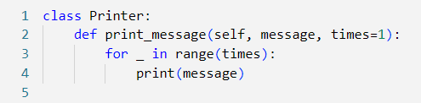

Task 2: Use the Printer Class
The program creates an instance of Printer and demonstrates calling the print_message method with different numbers of arguments.
printer.print_message("Hello") only passes the message argument, so the method defaults to printing the message once. printer.print_message("Hello", 3) passes both the message and times arguments, causing the message to be printed 3 times.

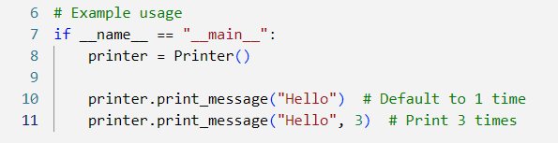

Output:
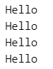

We simulate method overloading in Python using default arguments. The Printer class's print_message method is flexible enough to be called with one or two arguments, and its behaviour adjusts accordingly.

